HỆ THỐNG QUẢN LÝ ĐỖ XE THÔNG MINH DỰA TRÊN SINH TRẮC HỌC TÍCH HỢP VÍ THANH TOÁN TỰ ĐỘNG DÀNH CHO SINH VIÊN
BIOMETRIC-BASED SMART PARKING SYSTEM WITH INTEGRATED AUTOMATED STUDENT PAYMENT
Students: Le Duong Song An¹, Pham Thanh Pha², Truong Van Hoang Nguyen³, Phan Viet Hung⁴, Vo Duc Kim Hung⁵
Classes: 24ES^{1,2,3,4,5},
Faculty of Advanced Science and Technology, University of Science and Technology, The University of Danang
Email: 123240054@sv1.dut.udn.vn, 123240093@sv1.dut.udn.vn, 123240074@sv1.dut.udn.vn, 123240073@sv1.dut.udn.vn, 123240089@sv1.dut.udn.vn
Supervisor: Dr. Doan Quoc Khoa, MS. Nguyen Huu Lap Truong
Faculty of Advanced Science and Technology, University of Science and Technology, The University of Danang
Email: dqkhoa@dut.udn.vn, nhltruong@dut.udn.vn

Tóm tắt – Trong bối cảnh chuyển đổi số tại các trường đại học, hệ thống quản lý bãi xe dựa trên thẻ RFID truyền thống bộc lộ nhiều hạn chế về bảo mật và khả năng định danh chính xác người dùng. Báo cáo này đề xuất thiết kế và phát triển một hệ thống bãi đỗ xe thông minh dựa trên sinh trắc học tích hợp thanh toán sinh viên tự động (SPARK) nhằm thiết lập mối liên kết "một-đối-một" giữa danh tính sinh viên và phương tiện. Hệ thống sử dụng vi điều khiển ESP32 làm trung tâm, kết hợp cảm biến vân tay AS608 và nhận diện biển số bằng trí tuệ nhân tạo (ALPR) qua Webcam độ phân giải cao để tối ưu hóa tính an toàn tài sản. Điểm mới cốt lõi là sự chuyển dịch từ định danh vật lý sang định danh sinh trắc học kép, bên cạnh đó áp dụng kiến trúc bảo mật phân tán, dữ liệu vân tay nhạy cảm được lưu trữ cô lập tại thiết bị đầu cuối (Edge), trong khi các tác vụ quản lý logic được thực hiện bảo mật trên nền tảng đám mây Firebase. Hệ thống tích hợp toàn diện với ứng dụng di động SPARK dành cho sinh viên đăng ký dấu vân tay và ví điện tử, hỗ trợ thanh toán tự động cùng cơ chế ủy quyền lấy xe tạm thời trong những trường hợp cấp thiết. Kết quả thực nghiệm khẳng định hệ thống vận hành ổn định 95%, nâng cao tính minh bạch trong việc bảo vệ an ninh, quản lý tài chính và hiệu quả vận hành bãi xe trong giờ cao điểm tại môi trường Smart Campus.

Từ khóa – AIoT, định danh sinh trắc học kép, AS608, ALPR, bảo mật phân tán, SPARK, tích hợp thanh toán tự động, cơ chế ủy quyền, Smart Campus.
Abstract – In the context of digital transformation within universities, traditional RFID-based parking management systems have revealed significant limitations regarding security and accurate user identification. This report proposes the design and development of a biometric-based smart parking system with integrated automated student payment (SPARK) to establish a "one-to-one" link between student identity and the vehicle. The system utilizes an ESP32 microcontroller as the central hub, combining an AS608 fingerprint sensor and AI-driven Automatic License Plate Recognition (ALPR) via a high-definition webcam to optimize asset security. The core innovation lies in the transition from physical identification to dual-factor biometric identification, alongside the application of a distributed security architecture. In this framework, sensitive fingerprint data is stored in isolation at the network edge, while logic management tasks are securely executed on the Firebase cloud platform. The system is fully integrated with the SPARK mobile application, allowing students to register fingerprints and manage e-wallets, supporting automated payments and a temporary vehicle delegation mechanism for urgent cases. Experimental results confirm that the system operates stably at …%, enhancing transparency in security protection, financial management, and operational efficiency during peak hours within a Smart Campus environment.

Key words - AIoT, dual-factor biometric identification, AS608, ALPR, distributed security, SPARK, integrated automated payment, delegation mechanism, Smart Campus. .

Introduction
In modern smart campus environments, traditional RFID-based parking systems face significant security vulnerabilities, such as card sharing, and high latency within centralized cloud architectures. Transmitting large image files for remote AI recognition causes delays at entry points and often requires expensive local servers for mitigation. This project proposes SPARK, a Biometric-based Smart Parking System utilizing a distributed Edge-to-Cloud architecture. SPARK replaces physical credentials with dual-factor authentication: Fingerprint recognition and Automatic License Plate Recognition (ALPR).
By shifting intensive processing to the network edge, the system achieves near-instantaneous response times. At the Deep Edge layer, biometric data is processed locally within the AS608 sensor, while the Edge Server layer handles license plate recognition using EasyOCR on-site. Consequently, only lightweight text payloads are transmitted to the Firebase Cloud for asynchronous transaction logging and e-wallet management. This hybrid approach eliminates expensive hardware requirements and internet dependency for real-time gate control. It ensures a secure, scalable, and cost-effective solution for small-scale facilities, establishing a strict "one-to-one" link between student identity and vehicles.

System Design and Block diagram
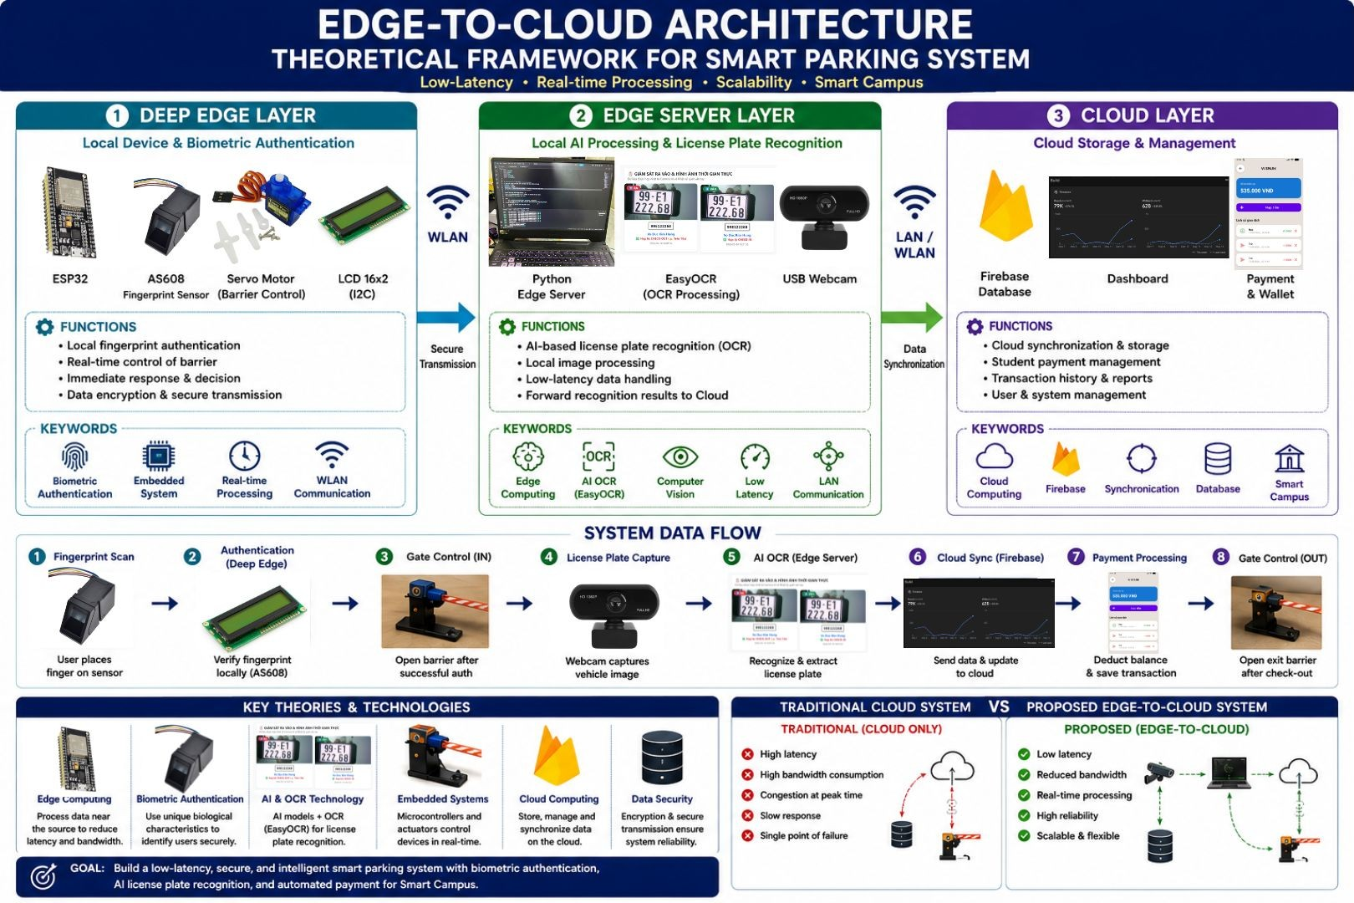
Fig. 0 System Design
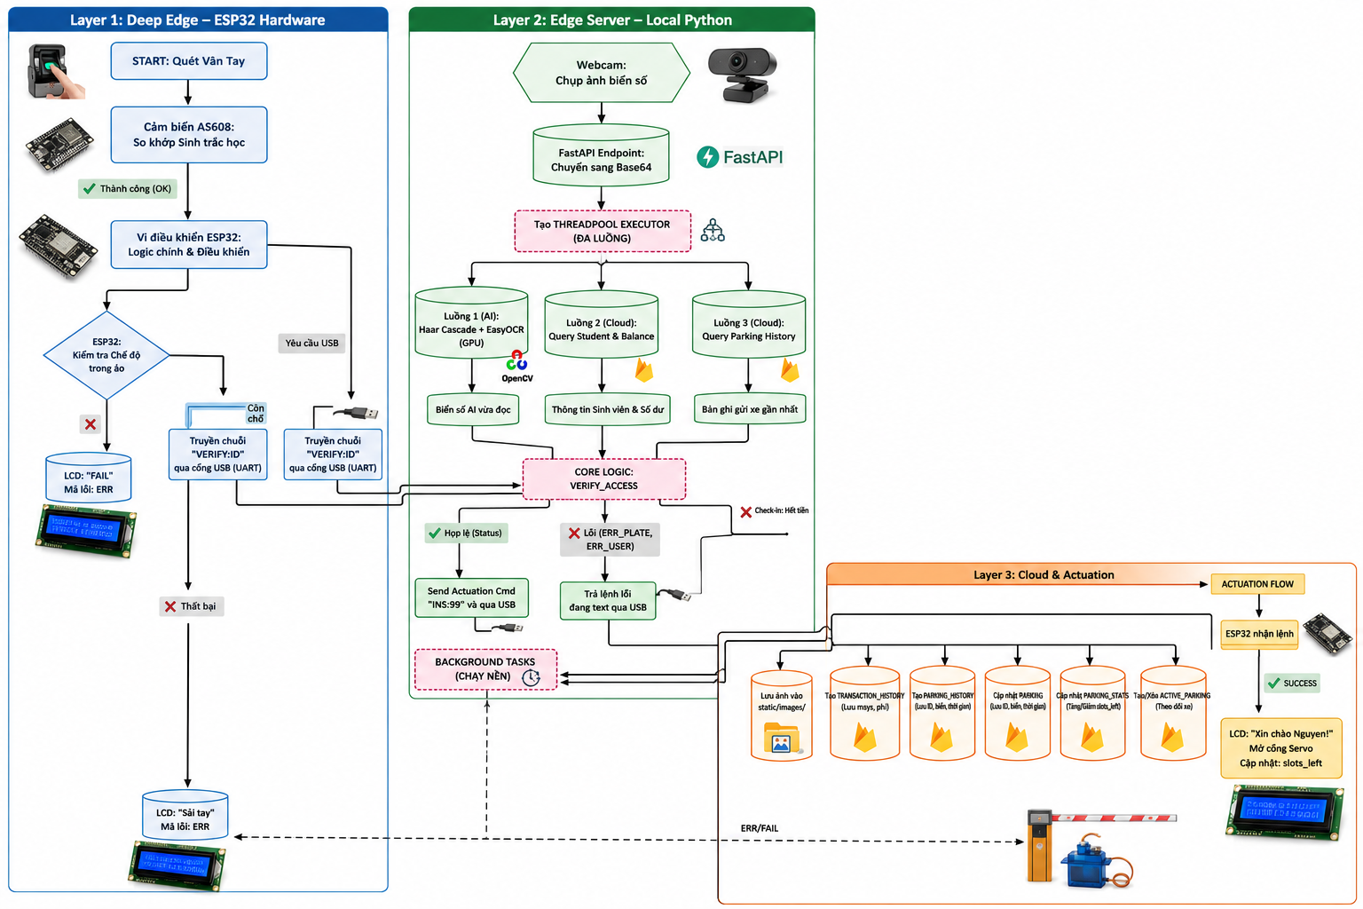
Fig. 1 Block Diagram
- Firmware:
In the distributed architecture of the SPARK system, the ESP32 microcontroller does not operate as a standalone server but functions as a "Deep Edge Controller" [1]. Its core functionality is to acquire real-time biometric signals and control physical actuators, while entirely offloading intensive graphical processing (AI) and networking tasks to the Edge Server layer.
The ESP32 serves as a centralized internal routing hub that orchestrates multiple peripheral modules via industry-standard protocols. For biometric authentication, it interfaces with the AS608 optical fingerprint sensor utilizing the Universal Asynchronous Receiver-Transmitter (UART) protocol. The microcontroller strictly triggers the sampling phase, ensuring that minutiae extraction and template matching are processed securely within the sensor's embedded Digital Signal Processor (DSP). Furthermore, it employs the Inter-Integrated Circuit (I2C) protocol to drive a 16x2 Liquid Crystal Display (LCD), delivering immediate visual feedback to the users. For physical actuation, the firmware utilizes Pulse Width Modulation (PWM) signals to independently operate two SG90 servo motors, which function as the mechanical barriers for the symmetrical entry and exit lanes. Besides, it is strategically configured to communicate with the local Edge Server via a physical wired connection (USB to UART) at a high baud rate of 115200, primarily aimed at bandwidth optimization. Instead of transmitting substantial data packets or heavy image payloads over wireless networks, the ESP32 exchanges ultra-lightweight text strings. This payload minimization strategy drastically reduces network congestion and guarantees near-instantaneous barrier response times.
- Software
4.1. Localhost server
Operating as the critical "Edge Server Layer" within the SPARK architecture, the localhost server is developed using Python and the FastAPI framework to ensure high-performance, asynchronous RESTful API communication. Its primary function is to bridge the Deep Edge hardware (ESP32) and the Firebase Cloud, taking over computationally intensive tasks to eliminate network bottlenecks.
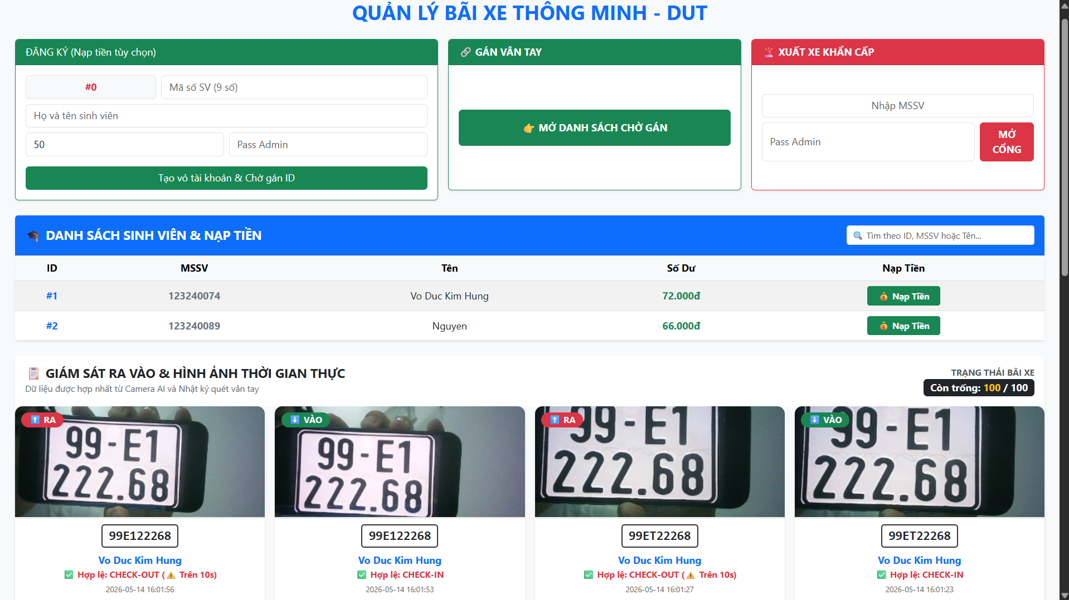
Fig. 1 Web interface
Upon receiving a verification request from the gateway, the server executes Automatic License Plate Recognition (ALPR) entirely on the local machine. By combining OpenCV’s Haar Cascades for rapid plate localization and GPU-accelerated EasyOCR for character extraction, the system successfully processes vehicle registration plates without transmitting heavy image payloads over the internet.
To achieve near-zero latency for the physical barriers, the server employs a highly optimized execution flow. It utilizes Multi-threading to run the AI image processing and cloud data fetching simultaneously. Furthermore, once the dual-factor verification (Biometrics and ALPR) is validated, the server immediately issues the actuation command to the ESP32. The heavy database operations—such as updating e-wallet balances and logging entry/exit timestamps—are offloaded to Background Tasks, executing silently without forcing the hardware to wait. Additionally, the localhost server hosts a comprehensive web dashboard, allowing administrators to monitor real-time traffic, manage user deposits, and perform manual emergency overrides.
4.2. SPARK application
SPARK (Smart Parking) is an application that aims towards promoting an interactive approach to traditional parking by merging convenience with sophisticated logging and tracking tools; it sets a new standard for how campus services should operate in a connected age.
User-Friendly Interface: The application prioritizes a minimalist design to ensure students can navigate features with zero learning curve. Also, the included real-time status tracker allows users to view live parking availability and specific slot locations. This reduces "cruising time," lowering campus carbon emissions and saving user time.
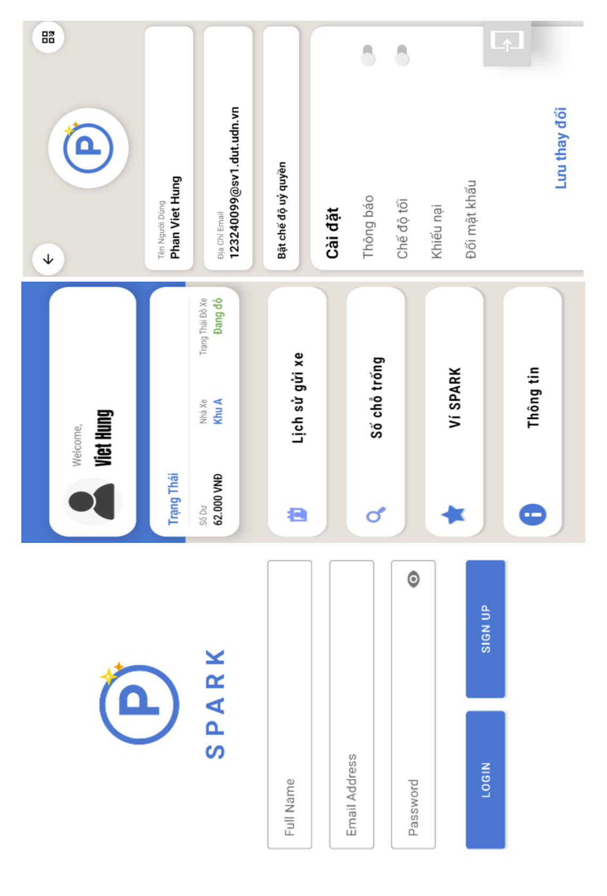
Fig. 2 User interface
SPARK also features an online deposit system through the use of a built-in wallet feature that encourages a shift away from cash, supporting the broader digital transformation of the campus. Along with comprehensive transaction logs where every deposit and payment is recorded and updated in real time, providing users with financial clarity and reducing disputes.
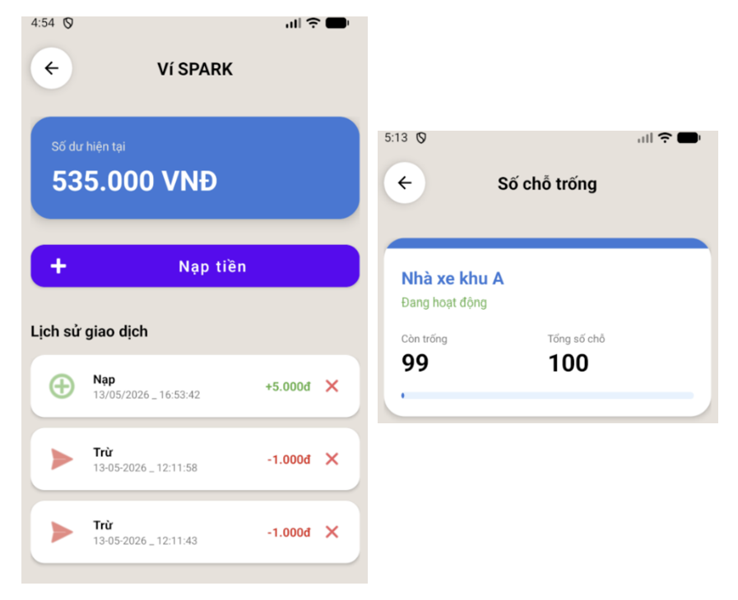
Fig. 3 Online payment
Alongside with transaction history, the added parking history viewer offers a centralized log of all entry and exit events. This data is invaluable for identifying usage patterns and security purposes. In case of emergencies, the dedicated delegation mechanism allows users to delegate parking access during emergencies, ensuring flexibility without compromising system integrity.
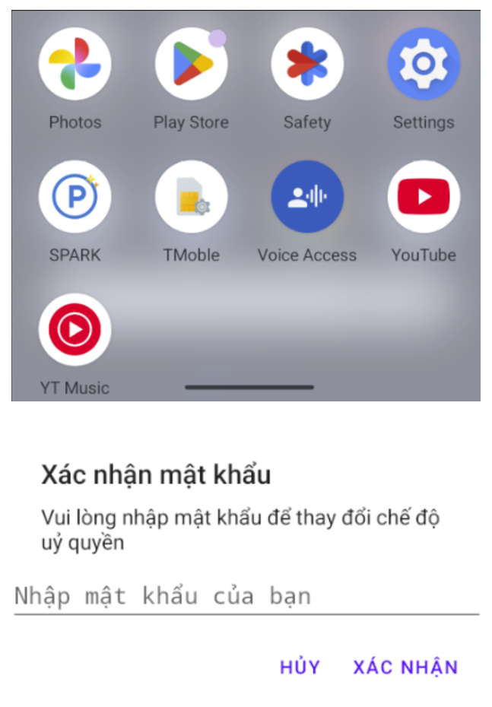
Fig. 4 Delegation mechanism
4.3. Firebase cloud
Firebase acts as the backbone for SPARK, transforming a local project into a robust cloud-ready solution using Firebase’s real-time capabilities to sync data across environments. It also provides the security needed for transactions and the real-time speed required for effective parking slot tracking .
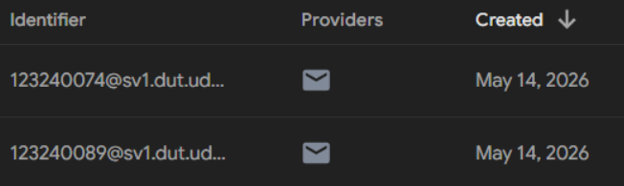
Firebase Authentication handles user sign-in (email/password or university ID). It ensures users can only view their own private details (balance, parking status, parking history,... )
Fig 5. Firebase Authentication
The Firestore database will act as the central repository for all SPARK operational data. Unlike traditional SQL databases, its NoSQL, document-oriented structure allows for high scalability and flexible data modeling [2].
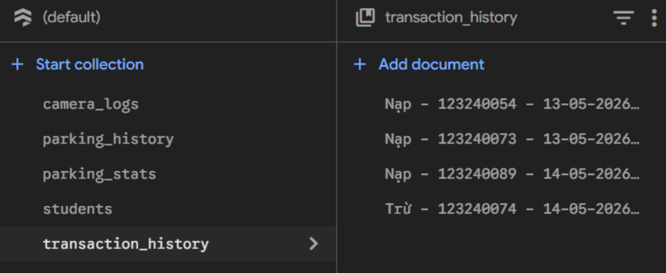
Fig. 6 Firestore Database

Hardware
5.1. Central Processing Block
The ESP32 was selected for the SPARK system due to its high integration and cost-efficiency. Its on-chip Wi-Fi and Dual-mode Bluetooth eliminate external modules, reducing PCB footprint and lowering the total Bill of Materials (BOM) [3, 4]. Optimized for the Firebase Arduino Client, the ESP32 provides hardware-accelerated encryption and JSON parsing, ensuring secure transmission of sensitive financial data [5].
For 24/7 campus operation, the chip’s Deep Sleep modes and GPIO interrupt capabilities minimize energy consumption without sacrificing responsiveness [1, 3]. Additionally, support for Over-The-Air (OTA) updates and a vast open-source ecosystem allow for remote maintenance and scalability. These features collectively ensure that the SPARK hardware remains a secure, low-power, and future-proof foundation for smart campus infrastructure [3].
5.2. Biometric sensing layer
The system utilizes the AS608 optical fingerprint sensor for primary authentication, replacing traditional RFID cards. Equipped with an integrated DSP, the module performs feature extraction and template matching locally within its internal flash memory [6]. This "Deep Edge" mechanism secures sensitive data by preventing the network transmission of raw biometric images, thus mitigating identity theft risks [7].
Additionally, local matching eliminates cloud-based verification latency, providing near-instant identification [8]. This high-speed process ensures efficient traffic flow at parking entrances, maintaining operational throughput during peak campus hours [9].
5.3. Vision Acquisition Block
To achieve dual-factor verification, the hardware incorporates a High-Definition (HD) USB Webcam specialized for capturing vehicle license plates. Unlike low-cost embedded cameras that suffer from rolling shutter artifacts and low dynamic range, the HD webcam provides 1080p frames, enabling the extraction of clear alphanumeric characters even under suboptimal lighting. The camera acts as a raw data source, streaming compressed JPEG frames to a local Edge Server. This server executes AI-driven Optical Character Recognition (OCR) locally, offloading the heavy computational burden from the microcontroller and establishing a high-accuracy, verifiable link between the driver's biometric ID and the vehicle’s physical registration.
5.4. Actuator/Display Interface
The system manages user interaction and physical access through an OLED display and a Servo motor. The OLED, utilizing the I2C protocol, provides high-contrast visual feedback for authentication and e-wallet balances, ensuring outdoor readability while minimizing GPIO usage [10, 11].
Simultaneously, an SG90 Servo acts as the mechanical barrier, driven by Pulse Width Modulation (PWM) from the ESP32’s hardware timers for precise angular control [12]. Upon successful verification, the barrier rotates 90 degrees and automatically resets after a predetermined delay. This automated logic ensures a transparent entry process and optimizes vehicle throughput during peak campus hours [13].
5.5. Power Management and Decoupling Strategy
To ensure long-term reliability, the system is powered by a 5V/5A switching power supply. A critical design feature is the mitigation of transient voltage sags caused by the servo motor's inrush current. By placing a 1000µF electrolytic capacitor in parallel with the power rail, the system creates a local energy reservoir that buffers against fluctuations. This decoupling strategy prevents ESP32 resets and Wi-Fi disconnections, guaranteeing continuous operational integrity for the smart parking station.

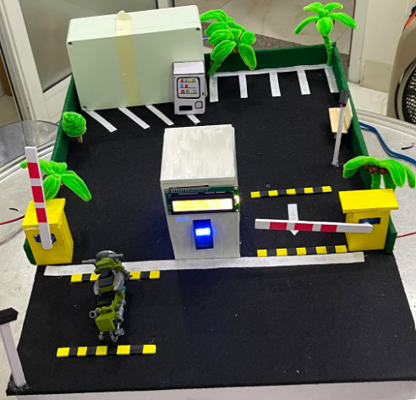
6. Implementation and model result:
Fig. 7 Working miniature model
To validate the SPARK ecosystem before full-scale campus deployment, a miniature model serves as a "Proof of Concept." This model simulates the physical interaction between vehicles and the digital infrastructure (Firebase/SPARK App), allowing for rigorous testing of the delegation logic and real-time slot tracking. The miniature model uses low-cost, high-efficiency components to replicate its full-size counterpart’s functions.

7. Conclusion:
In this study, the fundamental principles of The development of the SPARK system represents a significant advancement in decentralized infrastructure for modern smart campuses. By shifting critical authentication and recognition tasks from a cloud-centric model to a multi-layered Edge Computing architecture, the project effectively overcomes traditional bottlenecks like processing latency and network dependency. The synergy between the "Deep Edge" biometric processing of the AS608 sensor and localized AI-driven license plate recognition ensures high operational efficiency and system resilience, even during internet instability.
From a hardware perspective, the project successfully demonstrates the power of distributed coordination. The ESP32’s dual-core architecture enables seamless management of real-time actuators alongside high-level cloud logging, ensuring deterministic response times for every vehicle entry. Furthermore, the integration of robust signal routing and power decoupling strategies proved essential for maintaining system integrity under electromechanical stress. These milestones prove that distributing computation closer to the point of origin enhances speed, security, and scalability, providing a cost-effective foundation for the digital transformation of university infrastructure.
Looking forward, while the current SPARK prototype has achieved its primary objectives, there remains significant potential for further evolution. Future research will focus on... Additionally, the development of a dedicated mobile interface for real-time parking space monitoring and remote wallet management will be considered to further improve the user experience. Ultimately, the SPARK system stands as a robust proof-of-concept for the future of digital transportation, promising a more seamless and automated commuting experience for the entire campus community.
Reference
[1] W. Shi, J. Cao, Q. Zhang, Y. Li, and L. Xu, "Edge Computing: Vision and Challenges," IEEE Internet of Things Journal, vol. 3, no. 5, pp. 637-646, Oct. 2016.

[2] Ramzan, Tahir & Alwin, Greyson. (2023). Comparative Study of SQL vs. NoSQL for High-Performance E- commerce Databases. 10.13140/RG.2.2.34192.01286.

[3] Espressif Systems, "ESP32 Series Datasheet v4.1," Espressif Systems (Shanghai) Co., Ltd., 2023. [Online]. Retrieved from: https://www.espressif.com/sites/default/files/documentation/esp32_datasheet_en.pdf.
[4] M. A. Al-Fuqaha et al., "Internet of Things: A Survey on Enabling Technologies, Protocols, and Applications," IEEE Communications Surveys & Tutorials, vol. 17, no. 4, pp. 2347-2376, 2015.
[5] Firebase, "Firebase Client for Arduino - Documentation for ESP32/ESP8266," Mobizt, [Online]. Retrieved from: https://github.com/mobizt/Firebase-ESP32
[6] Ai-Thinker Technology, "AS608 Fingerprint Sensor User Manual v1.2," 2021. [Online]. Retrieved from: https://www.ai-thinker.com
[7] R. Das, "Biometric Security in IoT: Challenges and Solutions," IEEE Consumer Electronics Magazine, vol. 10, no. 4, pp. 62-68, 2021.
[8] S. Prabhakar, S. Pankanti, and A. K. Jain, "Biometric Recognition: Security and Privacy Concerns," IEEE Security & Privacy, vol. 1, no. 2, pp. 33-42, 2003.
[9] W. Shi and S. Dustdar, "The Promise of Edge Computing," Computer, vol. 49, no. 5, pp. 78-81, May 2016.
[10] J. Sinkevičius et al., "Analysis of OLED and LCD Display Technologies for IoT Applications," Journal of Electrical Engineering, vol. 71, no. 3, 2020.
[11] N. Sclater, "Mechanisms and Mechanical Devices Sourcebook," 5th ed., McGraw-Hill Education, 2011.
[12] M. Barr, "Introduction to Pulse Width Modulation," Embedded Systems Programming, 2001.
[13] K. Ogata, "Modern Control Engineering," 5th ed., Prentice Hall, 2010.

